Read-Write Programmer for AT88SCXX Model SC-RWP3

User Manual
- Introduction
The read-write programmer is specifically designed for the development and batch release of ATMEL’s AT88SCXXXX(AT88SC0104C/CA~25616C/CA) series cryptomemories devices (SO-8 packed, DIP-8 packed and card type). With the reading-writing configuration zone and user zone, the set has a range of functions such as simulated authentification (to users who signed the NDA agreement with ATMEL only), configuration file management and off-line programming (to program the device independently without a personal computer). Off-line programming,can realize the “Identification Number Nc” and(or) the “Issuer Code” automatic increase (make every device configuration each are not identical). Even if the fuse is blown (FUSES=#00H), all the data and configuration files inside can be retracted with the correct Gc and password.
Main features:
● Support AT88SC0104C/CA ~ 25616C/CA whole series
● USB Interface
● Off-line use
● Increase the Serial Number Automatically
● Save the setting data of AT88SCXXXX as a file
- Hardware
The device hardware is shown by the following illustration.
USB Interface: Connect the PC Communication port with USB cable to install.
RST: Button, to reset the set.
MODE(RST1): to select operation mode.
Multi operators mode: The set will be multi operators mode if you power on directly. In this mode, you have to press the relative button to start programming the device after you place a device in the socket.
Single operator mode: The set will be single operator mode if you press the MODE press when power on. In this mode, all of the eight devices in each socket will be programmed if you press any button (S1 to S8).
TEST: Button, to test the device connection in main socket. Green light means OK; if it does not light up, please check the conduction and direction of the device(SO-8 or DIP-8), the insertion direction (contact side face up) and the contact(card type).
CLR: Button, to clear the program counter of the set. Press the CLR and RST buttons simultaneously, then release the RST button to clear the program counter.
Power Switch: Switch to the ON side to connect power.
POWER SOCKET: DC input, voltage: 8V-15V.
PWR: Light up to indicate power on.
OK: Light up to indicate programming operation is all right.
CVCC: Light up to indicate the device in main socket is powered on.
Digital Display: Indicate the number of already-programed devices.
Card Socket: For card type device.
Special attention should be paid to the position of pin1 foot (indicated by the point in the above hardware illustration). Push TEST button to test the connection.

POWER
SOCKET
POWER
SWITCH
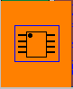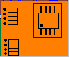
1
CLR

TEST

PROM

RST
MODE

PWR
OK
ON
CVCC
MAIN
SOCKET

LED displayer

OK
ERR
OK

ERR

OK

ERR

ERR

OK

ERR

OK

ERR

OK

ERR

OK

ERR

USB
Interface

S8
S1
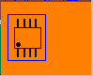
REQ
REQ

S7
S2
REQ

REQ

S6
S3
REQ

REQ

CARD SOCKET
OK

S5
S4
REQ

REQ

RS-232通信接口：安装时，用DB-9电缆与PC机COM口相连。

- Hardware Installation
Intall the device as follows:
1) Connect the DC input power.
2) Switch PWR to the ON side.
3) Connect the USB cable to a personal computer.
- If direct use USB power supply, ellipsis 1), 2) two steps.

- Software Installation and Use
4.1 Installation The USB Driver
Click CP210x_USB_Driver.exe under the "USB_Driver" Directory in the disc, According to clew installation. When there is shown below, please click "Install" button.
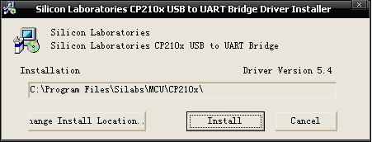
After successful installation, must according to clew restart PC, Otherwise software cannot be used properly.
- First use, Connect the PC port with USB cable, May be to discover new hardware.
- If correct installation the USB drive, please continue to install the software.
4.2 Install software
Click AT88SCxx&Card Reader V4.2.msi under the "AT88SCxx&Card Reader V4.2" in the disc.
Notice:
- Please make sure that it is stalled in a PC with an XP or higher oprating system.
- Close other application programs before installation.
- Install the hardware and connect power before starting-up the software.

- Instruction
Please refer to ATMEL for the configurations of various register and data memory models (AT88SC0104C/CA~25616C/CA).
  - Create the Configuration File( to create the configuration file from an old configuration file )
- Select Install Configuration File in the File menu. To reinstall, exit the the configuration zone/user zone interface.
- Select Read-Write Configuration Zone in the Device Operation menu to configure the area, press Esc to exit.
- Select Read-Write User Zone in the Device Operation menu to configure the area, press Esc to exit.
- Select Save Configuration File in the File menu, enter a file name and select Save. A configuration file (demo1.dem in the Design Sample directory) has been provided in the disc.
  - Create Configuration File ( to create the configuration file by reading configuration file from a device )
- Select the corresponding device model in the Device Selection menu, press Enter.
- Install the device and select Power on in the Device Operation menu to make the device power on.
- Select Read-Write Configuration Zone in the Device Operation menu to opeate.
- For unfused devices, enter the password and press Test Secure Code (SC). For the fused devices, press Lead-In G/P File to lead in all the Gc and password with *.gp file. Refer to Figure 5.1 for creating such a file.
- Press Read Configuration Zone to read the corresponding data, press Esc to exit.
- Select Read-Write User Zone in the Device Operation menu, press Read User Partition button to read data in the present user zone. To read/modify other user zone, select the user zone first and press Esc to exit after completion.
- Select Save Configuration File in the File menu, enter the file name and select Save.
  - Reading configuration zone and user zone will delete all the previously installed configuration files.
5.4 Compare Already-Installed Configuration File
Compare the already-installed configuration files to figure out which is the freshly-installed one.
- Select Install Configuration File in the File menu, and user configureation file will be installed and remain even in case of a power breakdown.
- Select Compare Configuration File in the File menu.
  - Off-Line Programming
5.5.1 Single device programming off-line(in main socket)
- Select Install Configuration File in the File menu. The installed user configuration file will remain even in case of a power off. For already installed configuration file, the first two steps can be skipped.
- Place a device to the main socket of the set.
- Press TEST to test the device. If it is correctly installed, the OK light will light up, otherwise, recheck the placement.
- Press the PROM button.
- When the programming operation is done, the buzzer will sound one time and the OK light will flicker once simultaneously and the counter is added 1; if the operation fails, the buffer will sound three times shortly and the OK light will not light up.
5.5.2 Multi devices programming off-line(in 8 sockets)
1.Select Install Configuration File in the File menu. The installed user configuration file will remain even in case of a power off. For already installed configuration file, the first two steps can be skipped.
2.Place a devices to the 8 sockets of the set.
3.Press relative REQ button(in multi operator mode) or press any REQ button(S1 to S8).

Notice:
  - Make sure that the device is correctly installed, the model of the configuration file match that of the device waiting to be programed, and the secure code match that of the device waiting to be programed also.
  - If you need to implementation the “Identification Number Nc” and(or) the “Issuer Code” automatic increase, please set the configuration files of the INC options when selected.
  - Fused device or device whose fuse value is not 07H cannot be programmed again.
  - Off-Line Programming can use external power source supply and also can directly use the USB by the PC power supply.

- Software Use
  - Power off and on
Press Power Connection to connect power and the “CVCC” indicator light will light up, which will go out when power breaks off.
  - Select Device Model
Select Device Model from the Device Selection menu as follows:
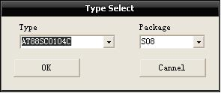
  - Verify Security Code
- Select Read-Write Configuration Zone from the Device Operation menu.
- Enter the secure code in the corresponding textbox.
- Press Test Secure Code.
If the fuse has not been blown and the secure code is correct, the configuration zone and user zone can be read or written.
  - Read-Write Configuration Zone
- Operation before fuse is blown
After selecting Read-Write Configuration Zone in the Device Operation menu, the following window will pop up. Enter secure code to test the device before operation. After installing the configuration file, any reading operation will delete the input data (without changing the configuration file).
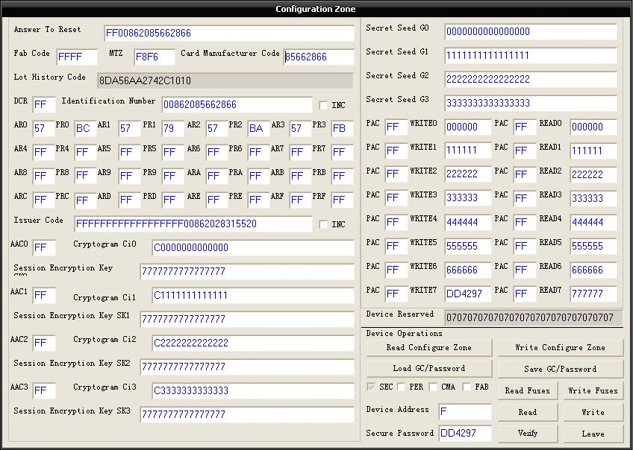
The following dialog box will pop up if the AR or PR is double-clicked.
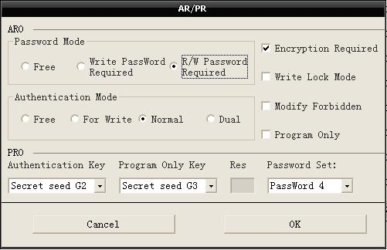
The following dialog box will pop up, if DCR is double-clicked.
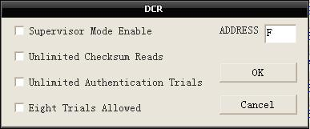
Notice:
- For fused device, secure code can no longer be verified. The correct Gc/Password must be lead-in before operation to ensure the device to be able read the real data inside, otherwise, some AAC or PAC may not be turned into FFH or the device may be locked up (cannot be used again). To avoid this, save the Gc/Password before the fuse is blown, and be careful when leading-in the Gc/Password.
2. Operation after the fuse is blown.
The configuration zone cannot be operated in. The Gc/Password must be lead-in before operation. If operation is already conducted in the user zone, repower on the device to correctly read the data inside after power off .
  - Read-Write User Zone
To read the correct data, select the device model before read-write operation.
Press Read User Partition to display data in the corresponding user zone.
If data is modified, press Write User Zone to write it into the device, one user zone can be written once; re-select the user zone to write others.
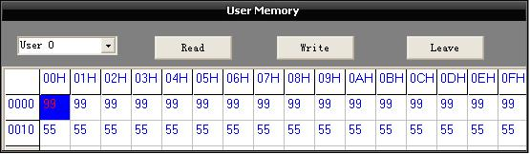
  - Simulated Authentification
Verify secure code and make sure the fuse has not been blown before operation. Select Simulated Authentification in the Device Operation menu to see the the following box. The simulated authentification is located in the 02H zone.
Open only to the user who signed the NDA agreement with the ATMEL.
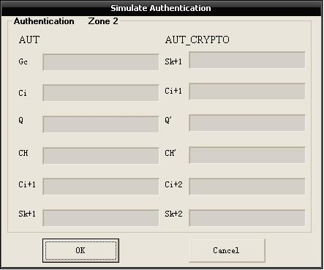
Questions and Anwsers
- Do not press any key when the device is communicating with the PC.
- Connect and correct installation the USB driver before starting up.
- Reading of the configuration zone and user zone will delete all the previously installed configuration file.
- If you need to implementation the “Identification Number Nc” and(or) the “Issuer Code” automatic increase, please set the configuration files of the INC options when selected. This function only applies to off-line programming. Reading configuration zone will automatically remove INC options.
- Before programming, make sure the device is correctly installed, the model of the configuration file match that of the device waiting to be programmed, and the secure code of the configuration file match that of the device waiting to be programmed.
- Secure code cannot be verified if the fuse is blown. Lead in the correct Gc/Password before operation to ensure the device to read the real data inside; otherwise, some AAC or PAC may not be turned into FFH or the device may be locked up (cannot be used again). To avoid this, save Gc/Password, and be careful when leading-in the Gc/Password.
- The present device does not support off-line programming in the following situations: the SO8 and DIP8 packed device whose fuse value is not 07H, device packed smart card whose fuse value is not 46H. Manual operation should be conducted in the above cases.
- To write fuse:The fuse can only be written after passing the secure code test. The fuse value of new SO8 and DIP8 packed device is 07H, and device packed smart card is 46H (that is, ATR and FAB are read only).
- The MTZ of the device packed smart card will resume its default value of F8F6H after power on again.
- The Secure Code in the configuration file is the password used for programming, while WRITE7 is the password for modifying the saved program. Usually, the users are recommended to change the Secure Code and take good care of the configuration file without blowing the fuse, if the device configuration is likely to be modified.
- The configuration file contains the user zone, data in the configuration zone, device model, fuse value, and the Secure Code for device programming.
- The default model after a normal startup is AT88SC0104C.
- Original Secure Code：
Type | Secure Code
AT88SC0104C | DD4297
AT88SC0204C | E54747
AT88SC0404C | 605734
AT88SC0808C | 22E83F
AT88SC1616C | 200CE0
AT88SC3216C | CB2850
AT88SC6416C | F7620B
AT88SC12816C | 22EF67
AT88SC25616C | 17C33A
- Suggest user not only modify passwords, but also modify ARx, PRx, ACCx, CIx, SKx when designing.
- The feet of the SO-8 packed device are as follows:
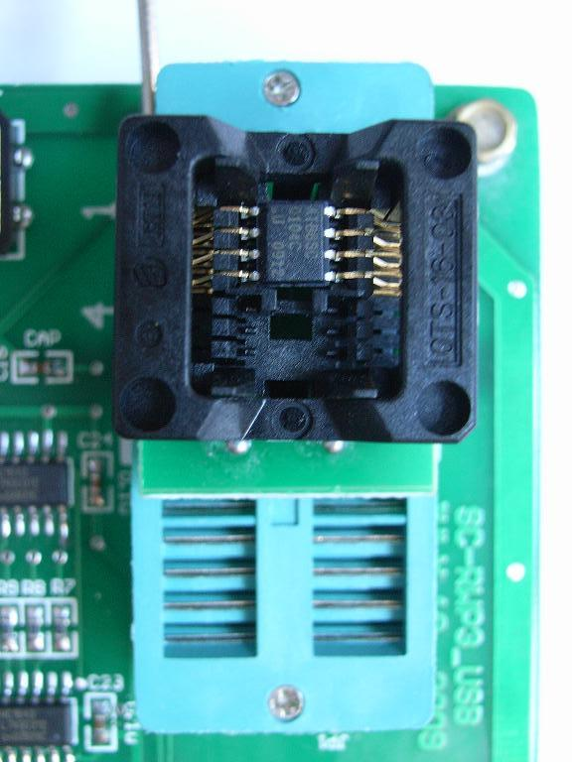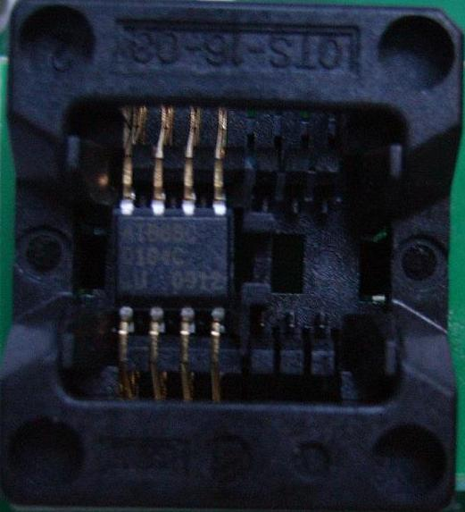
Figure 1 Main Socket Figure 2 SO-8 Socket

- About interface with DSP or CPU
1) Using I2C interface of a DPS or CPU directly,
2) Using GPIO pin.
If using GPIO pinas interface，suggest interface circuit as follows to avoid switching input/output direction:
Website of Setchief Electronics: www.setchief.com
Technical Support: 0086-20-85662866

